**Data Structures Lab 14**

*Ahmed Kasteer*

*20F-0336*

*Section 3D*

Question 1

#include<iostream>

using namespace std;

class adjacentmatrix

{

public:

int** arr;

int size;

adjacentmatrix(int s)

{

size = s;

arr = new int* [s];

for (int i = 0; i < s; i++)

{

arr[i] = new int[s];

for (int j = 0; j < s; j++)

{

arr[i][j] = 0;

}

}

}

void input(int** a)

{

int x, y;

cout << "Enter vertices in the matrix." << endl;

cout << "Enter row: ";

cin >> x;

cout << "Enter column: ";

cin >> y;

if (x < 8 && y < 8)

{

arr[x][y] = 1;

}

}

void display(int** a,int s)

{

for (int i = 0; i < s; i++)

{

for (int j = 0; j < s; j++)

{

cout << a[i][j] << " ";

}

cout << endl << endl;

}

}

};

void main()

{

int choice = 0;

cout << "Enter rows and cols for matrix representaion." << endl;

cout << "1) Input" << endl;

cout << "2) Display" << endl;

cout << "3) Exit" << endl;

adjacentmatrix obj(8);

while (choice != 3)

{

cout << "Enter choice: ";

cin >> choice;

switch (choice)

{

case 1:

obj.input(obj.arr);

break;

case 2:

obj.display(obj.arr, obj.size);

break;

}

}

}

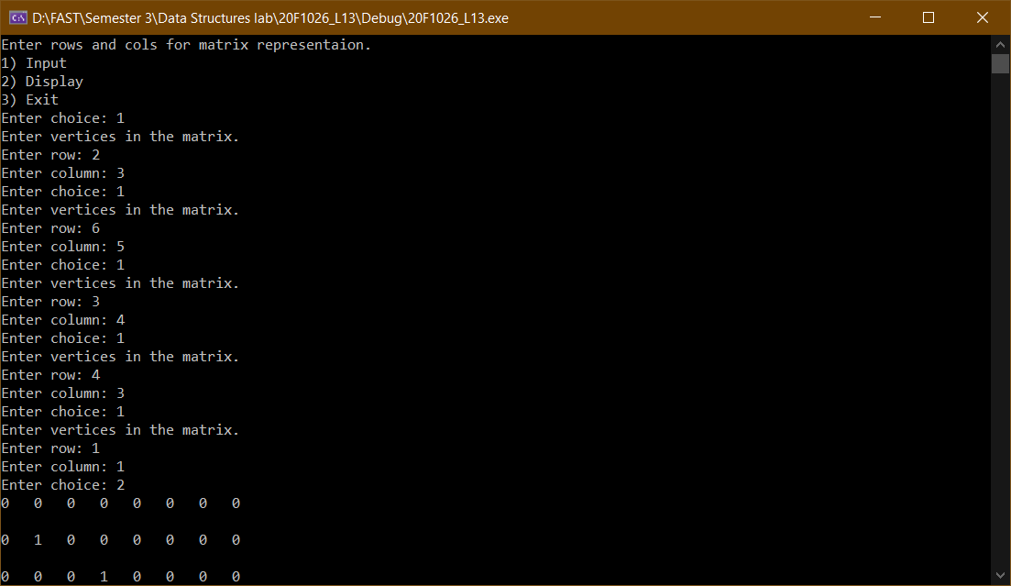

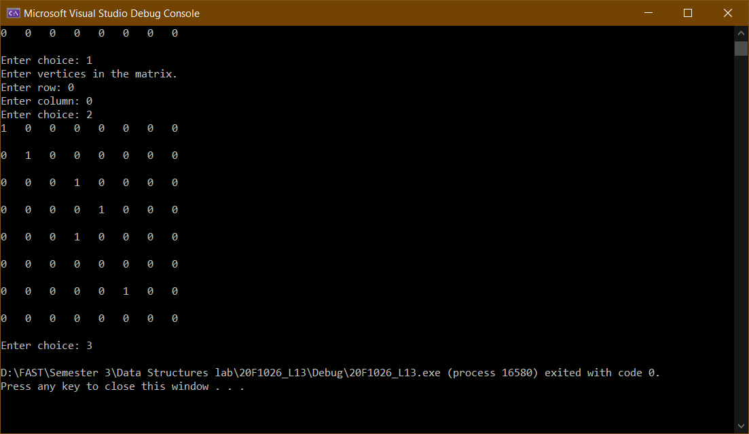

Question 2

#include<iostream>

using namespace std;

class adjacentmatrix

{

public:

int** arr;

int size;

adjacentmatrix(int s)

{

size = s;

arr = new int* [s];

for (int i = 0; i < s; i++)

{

arr[i] = new int[s];

for (int j = 0; j < s; j++)

{

arr[i][j] = 0;

}

}

}

void input(int** a)

{

int x, y;

cout << "Enter vertices in the matrix." << endl;

cout << "Enter row: ";

cin >> x;

cout << "Enter column: ";

cin >> y;

if (x < 8 && y < 8)

{

arr[x][y] = 1;

}

}

void display(int** a,int s)

{

for (int i = 0; i < s; i++)

{

for (int j = 0; j < s; j++)

{

cout << a[i][j] << " ";

}

cout << endl << endl;

}

}

};

void main()

{

int choice = 0;

int count = 0;

cout << "Enter rows and cols for matrix representaion." << endl;

cout << "1) Input" << endl;

cout << "2) Display" << endl;

cout << "3) Exit" << endl;

adjacentmatrix obj(8);

while (choice != 3)

{

cout << "Enter choice: ";

cin >> choice;

switch (choice)

{

case 1:

obj.input(obj.arr);

count += 2;

break;

case 2:

obj.display(obj.arr, obj.size);

cout << "Number of edges: " << count/2 << endl;

break;

}

}

}

